**Marudhar Kesari Jain College For Women,**

**Vaniyambadi. Thiruvalluvar University, Serkadu, vellore**

**Department of statistics**

**Tracing the Growth of the Global Community: A Population Forecasting Analysis**

*Project done by*

1. Swathi .G
2. Vanitha sri .S
3. Sathiya .V
4. Monisha .D

**Introduction**

**Overview**

Population growth is the increase in the number of humans on Earth. For most of human history our population size was relatively stable. But with innovation and industrialization, energy, food, water, and medical care became more available and reliable. Consequently, global human population rapidly increased, and continues to do so, with dramatic impacts on global climate and ecosystems. We will need technological and social innovation to help us support the world’s population as we adapt to and mitigate climate and environmental changes.

**Purpose**

Methods to predict the population are discussed further. The arithmetical Increase Method is mainly adopted for old and developed towns, where the rate of population growth.

Population forecasting is a method by which we calculate the future population of any city or region at the interval of n number of decade.

ratio method of forecasting future population this is also known as the ratio method of forecasting future population. In this method the census > population record is expressed as the percentage of the population.

dramatic growth has been driven largely by increasing numbers of people surviving to reproductive age, the gradual increase in human lifespan, increasing urbanization, and accelerating migration. Major changes in fertility rate have accompanied this growth. These trends will have far-reaching implications for generations to come.

We show how the world population grew over the last several thousand years and we explain what has been driving this change.

It is used for forecasting the population of those large cities which reach the saturation population.

This method is suitable for a large and old city with considerable development.

**Advantage**

As the population increases, the economy can benefit from a bigger talent pool, economies of scale and greater specialisation. All this can enable higher per capita income, which we have seen in major developed economies.

**Disadvantage**

Trying to reduce carbon and methane emissions to reduce global warming is relatively more difficult as the population.

There will be greater threat on natural habitats as a greater population has greater demand for housing and farmland. This will increase pressure to cut down forests to make way for farming and housing.

Higher population will lead to a greater consumption of non-renewable resources, leading to a faster depletion of natural resources.

Higher population will lead to greater pollution levels in air, water and land. Higher pollution is associated with a range of health issues, such as cancer and asthma. The pollution also harms animals and plants.

Soil degradation. To feed a growing planet, we have seen serious degrading of farmland (according to UN estimates) about 12 million hectares of farmland every year. This is due to factors, such as overgrazing, use of chemicals, climate change and use of chemicals.

**Future scope**

Current issues in population dynamics are discussed in the context of The Royal Society Discussion Meeting 'Population growth rate: determining factors and role in population regulation'. In particular, different views on the centrality of population growth rates to the study of population dynamics and the role of experiments and theory are explored. Major themes emerging include the role of modern statistical techniques in bringing together experimental and theoretical studies, the importance of long-term experimentation and the need for ecology to have model systems, and the value of population growth rate as a means of understanding and predicting population change. The last point is illustrated by the application of a recently introduced technique, integral projection modelling, to study the population growth rate of a monocarpic perennial plant, its elasticities to different life-history components and the evolution of an evolution.

Even though the pace of global population growth will continue to decline in the coming decades, world population is likely to be between 20 and 30 per cent larger in 2050 than in 2020.

quantitative study of human distribution in a particular area or space. Variation in population density due to environmental or geographical condition. The demographic phenomenon like mortality, growth rate, birth rate, etc. is studied

India is projected to have a population of 1.668 billion in 2050, ahead of China's 1.317 billion people by the middle of the century. India's population is set to rise to 1.515 billion in 2030, from 1.417 billion in 2022

**Brainstorm**



**Group idea**

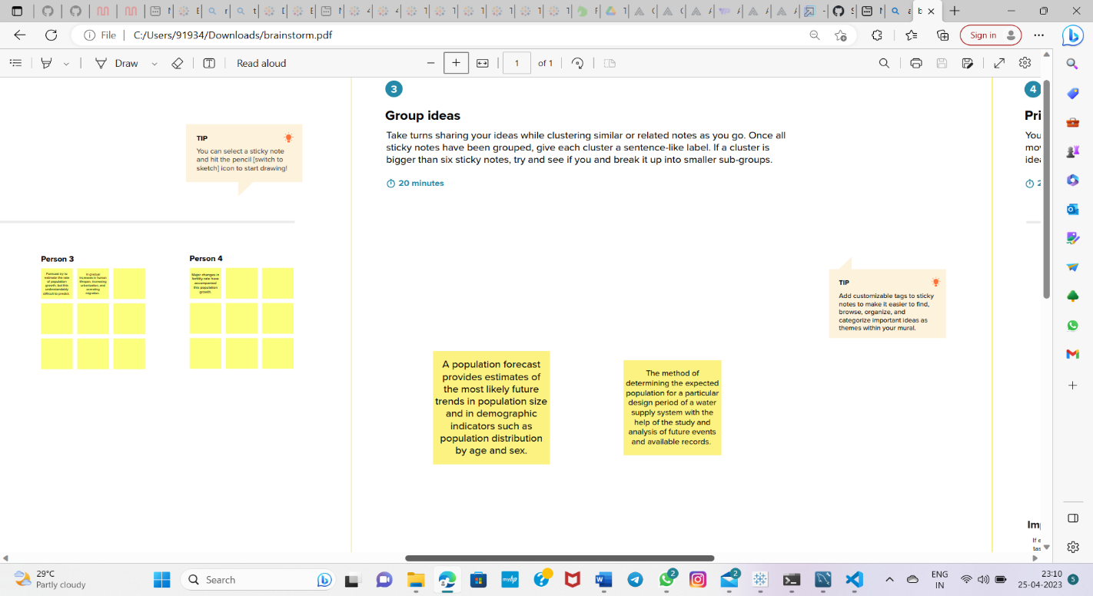

**Graph**

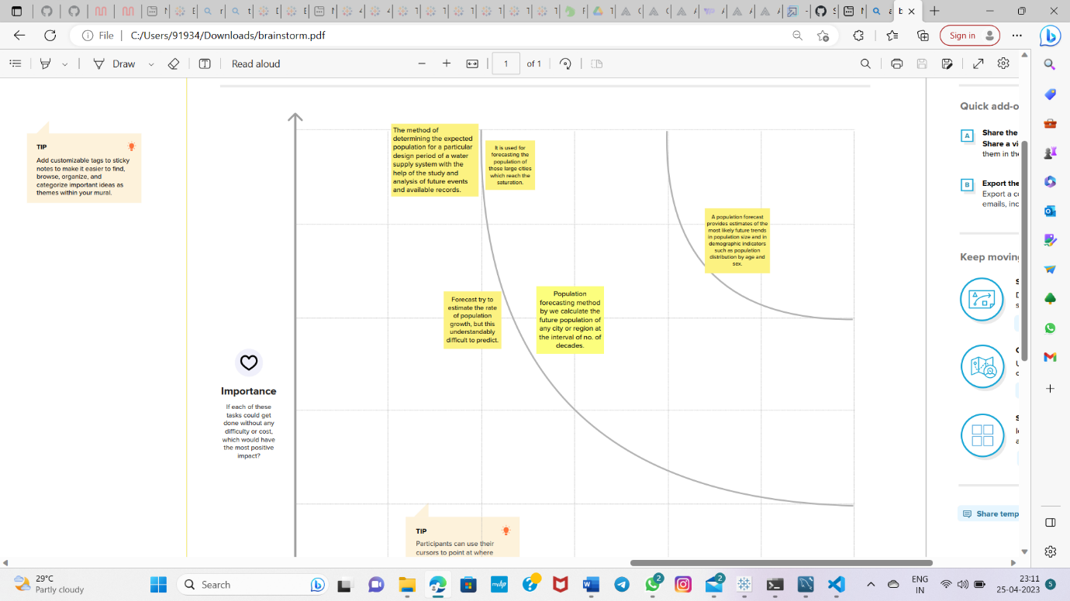

**Empathy mapping**

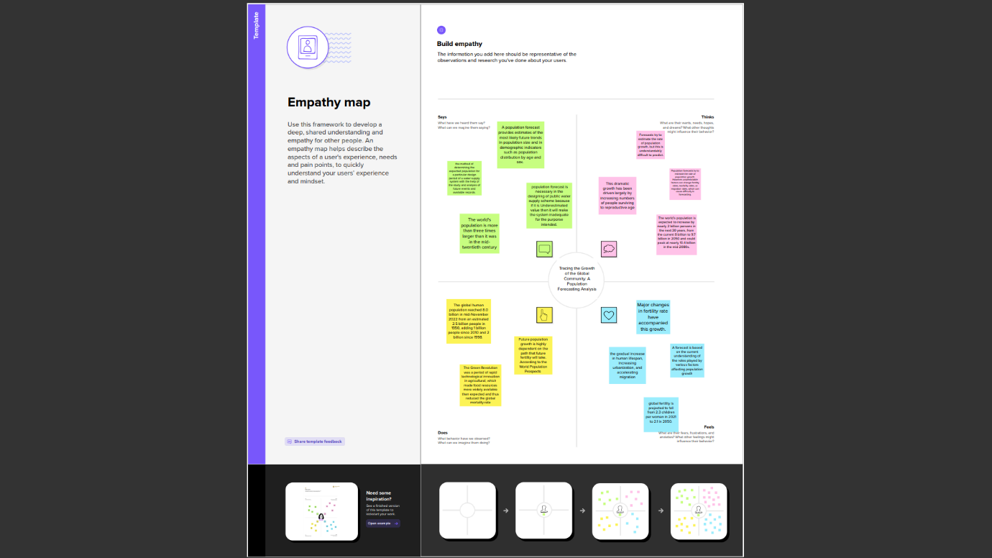

**Conclusion**

The current population of India is around 140 crores. According to certain reports, in the next few years, there will be a solid growth of population in India, and globally too. The population is the total number of human beings living in a city or the country. The Earth's current population is almost 7.6 billion people, and it is expanding. It is expected to surpass 8 billion people by 2025, 9 billion by 2040, and 11 billion by 2100